**DEPLOYING IN FLASK - ASSIGNMENT 4**

**Report date:** 21/03/2021

**Batch code:** LISP01

**Version:** 1.0

**Intern:** Ajaegbu Ebuka Emmanuel

**Submitted to:** Data Glacier

**STEP BY STEP FOR MODEL DEPLOYMENT**

**Step One:** The model was built in Python using the Random Forest Classifier Algorithm with the help of pandas, NumPy and sklearn

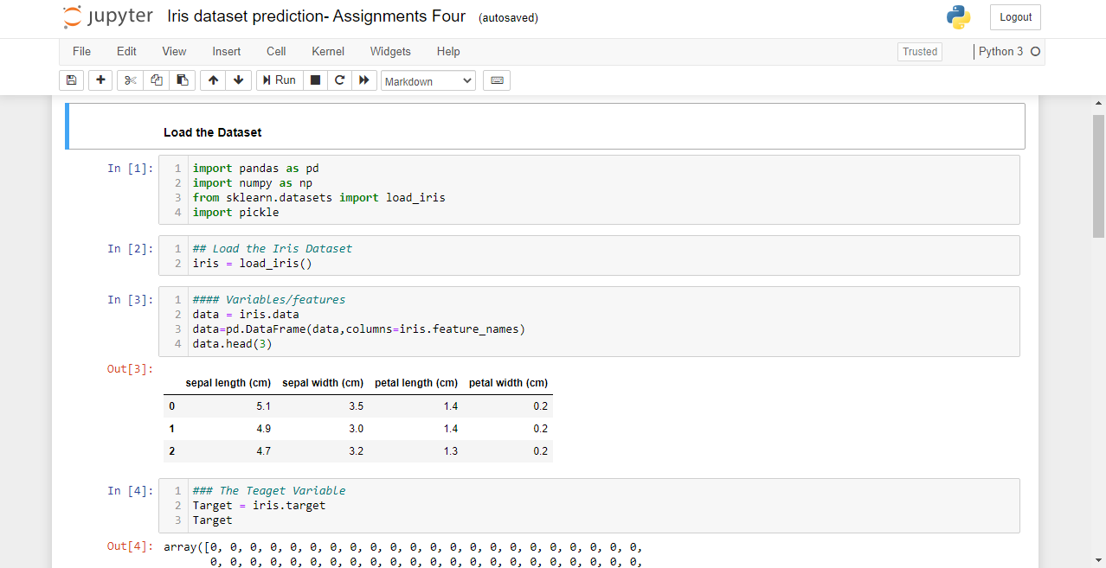

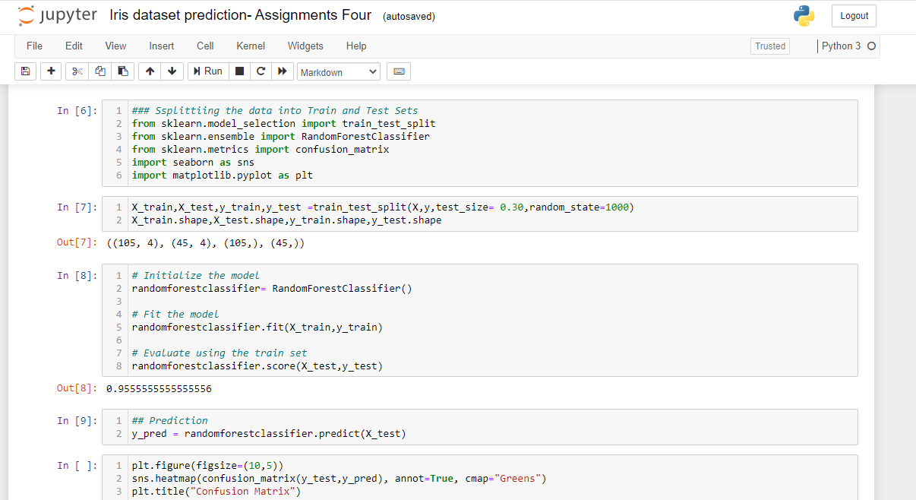

**Step two:** The model was serialized using pickle modules

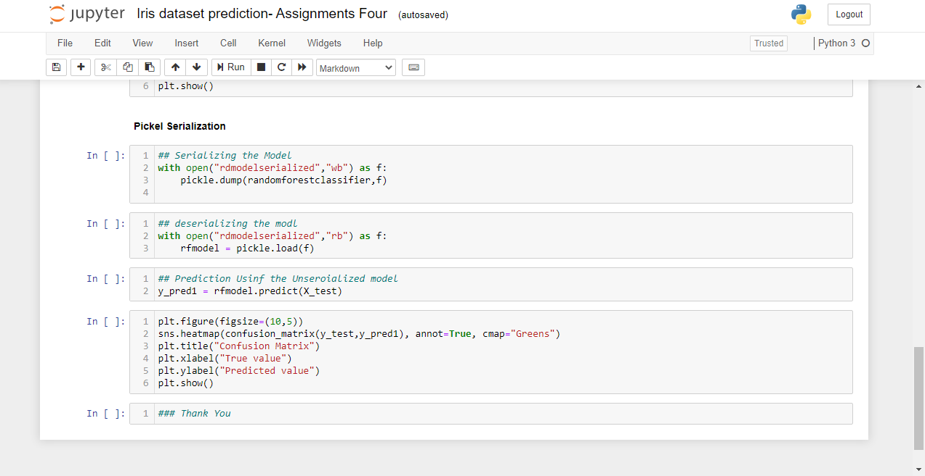

**Step Three:** Flask app was built with the help of the Flask, render_emplate, request, url_for methods. The serialized model was then imported and unserialized and the used for prediction

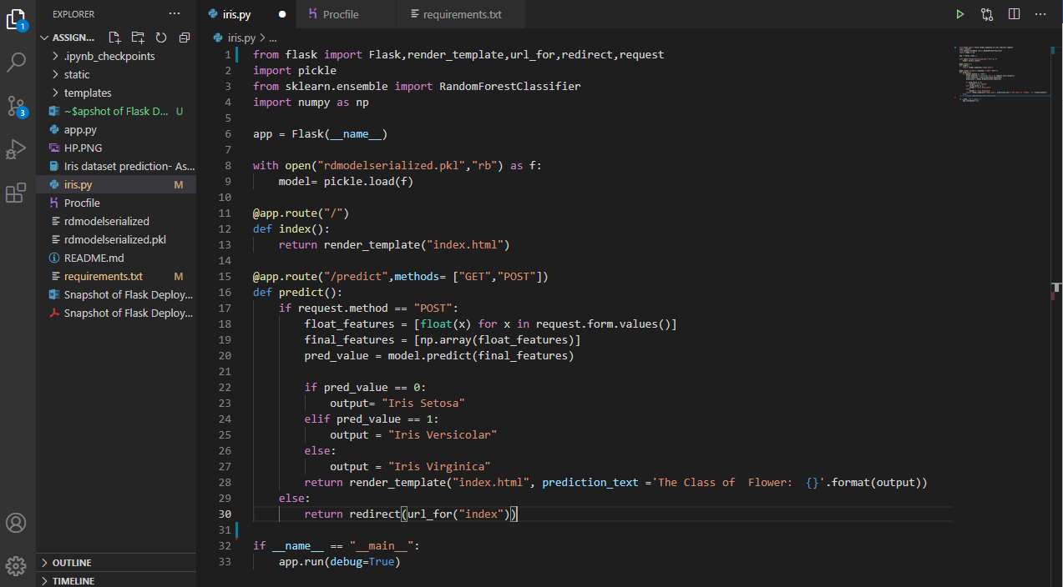

**Step Four:** The index.html file was created for building the structure of the websites. this file is stored in the templates folder

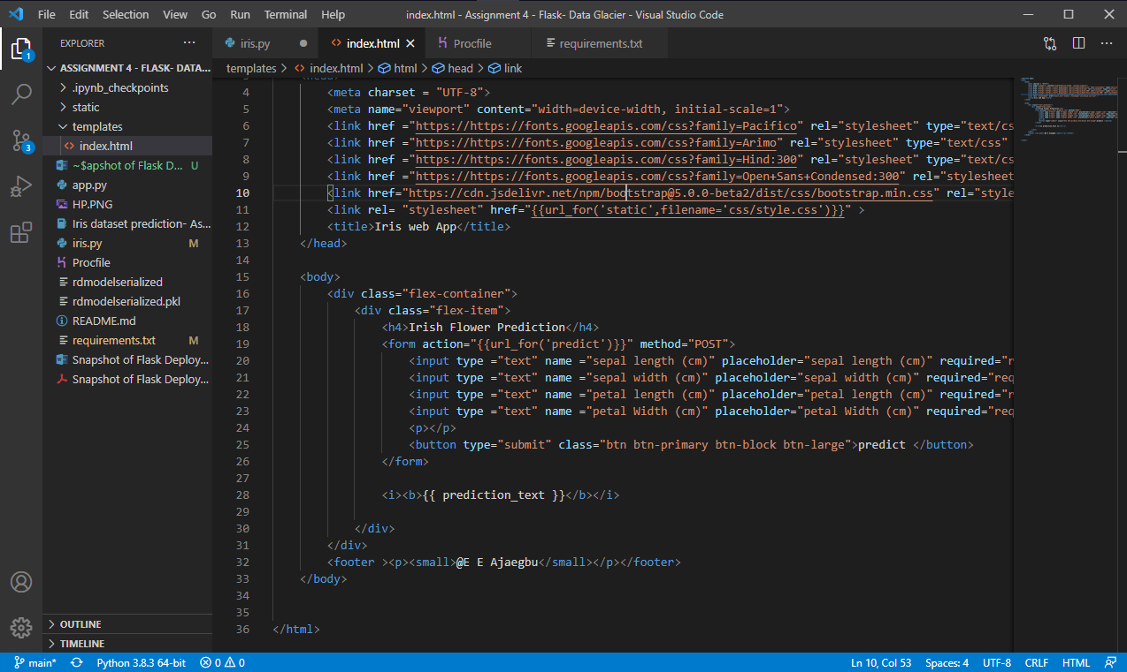

**Step Five:** The CSS file was created for styling the web app and for also bootstrapping.

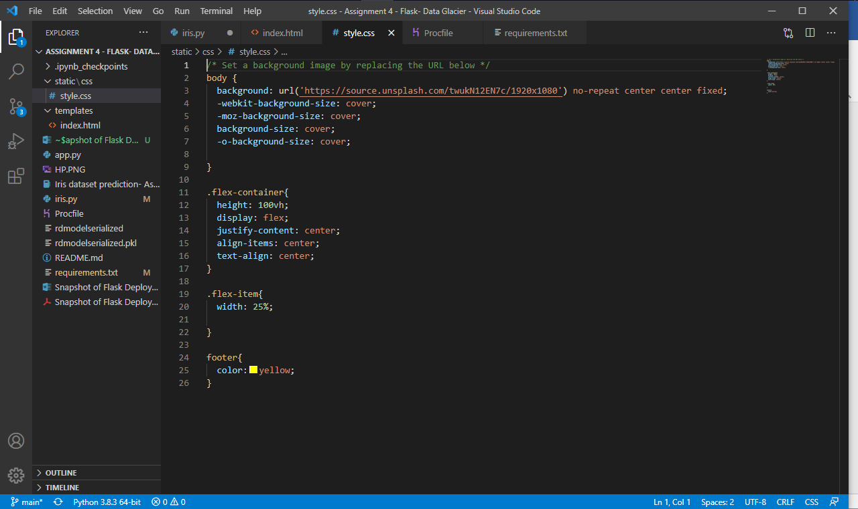

**Step Six:** Making Prediction Using the App

Before

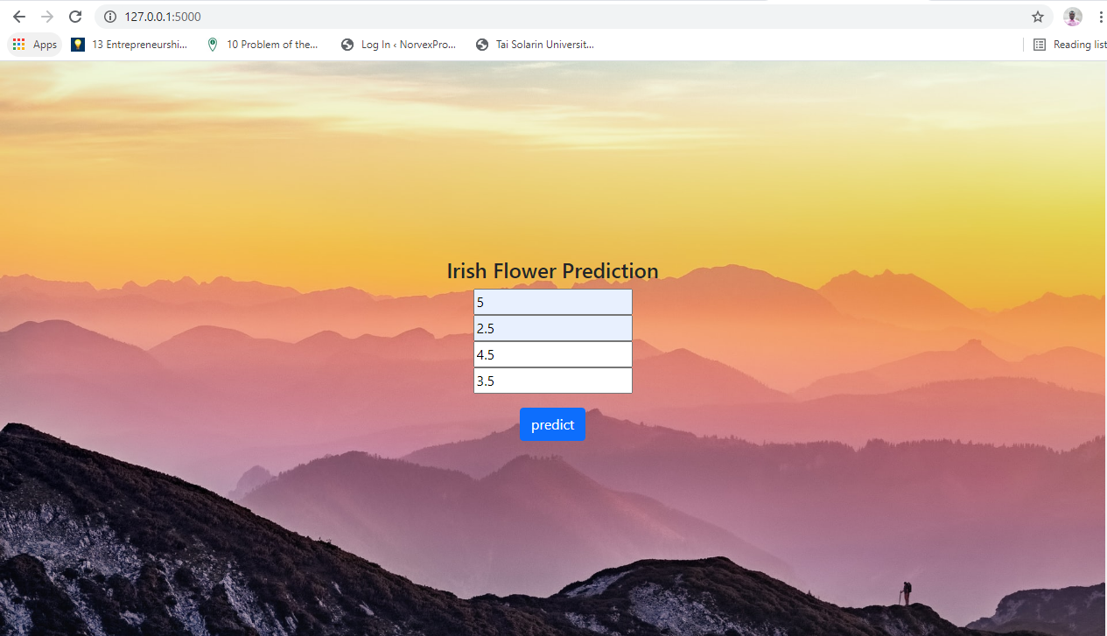

After

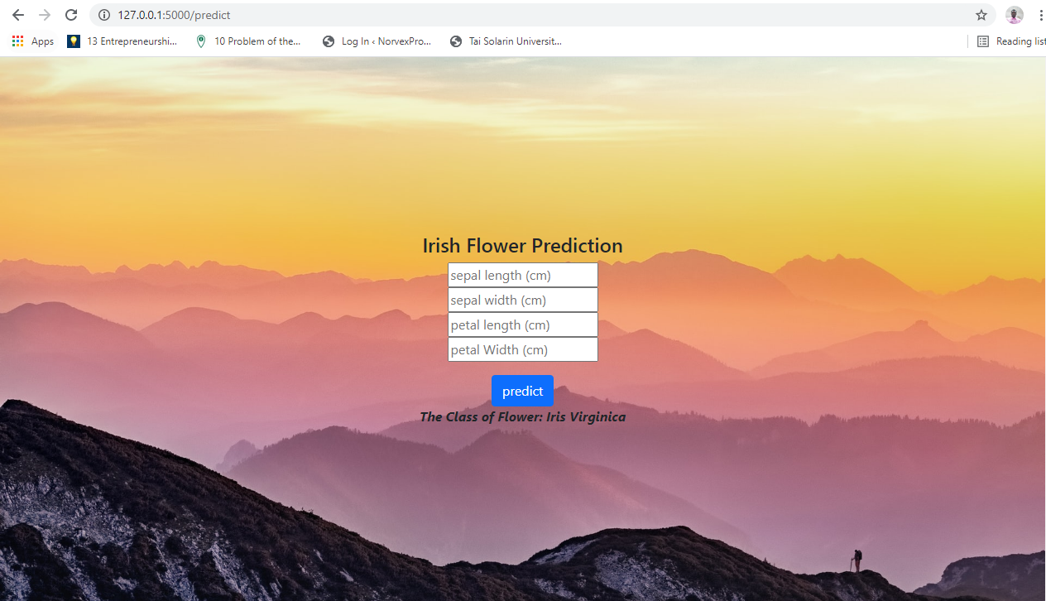

**Step Seven:** The files will then uploaded to GitHub

**Step Eight:** The web application will be deployed in the cloud.- Heroku